

**Chemistry Lab Simulation**

**By:**

101832

099972

An Information Systems Proposal document submitted to the faculty of Information Technology in partial fulfilment of the requirements for the bachelor of a degree in Informatics and Computer Science

31-Aug-2018

Cover page should not have a page number

**Declaration and Approval**

We declare that this project has not been submitted to Strathmore University or any other university for the award of a degree in Informatics and Computer Science or any other degree

101832:

Sign: ________________________ Date: ________________________

099972:

Sign: ________________________ Date: ________________________

Sharon Mugambi:

Sign: ________________________ Date: ________________________

**Abstract**

includingThe conduction of laboratory spell check your work, in Kenyan High Schools, has traditionally been confined to the school environment specifically, inside a laboratory. What is the problem with this?

What is the solution?

What methodology is used to implement the solution?

Despite the high number of students in a school, every student will have a chance to perform the experiments on their own and understand the various chemical reactions that take place. With this solution, students will be able to practise on their own and perform better in their Chemistry examinations.

Table of Contents

**Missing: Declaration**

Abstract

etc

Chapter 1: Introduction 1

1.1 Background 1

1.2 Problem Statement 3

1.3 Aim 4

1.3.1 Specific Objectives 4

1.3.2 Research Questions 4

1.4 Justification 4

1.5 Scope and Limitations 5

Chapter 2: Literature Review 6

2.1 Introduction 6

2.2 Current Technologies used in the area 6

2.2.1 PhET Interactive Simulations Technology 6

2.2.2 ChemCollective Technology 8

2.2.3 Virtual Chemistry Lab Technology 9

2.3 Existing Challenges in the use of the current systems 10

2.4 Gaps in the existing systems 11

Chapter 3: Development Methodology 12

3.1 Introduction 12

3.2 Software Development Methodology 12

3.3 System Analysis 13

3.3.1 Functional requirements 13

3.3.2 Non-Functional requirements 14

3.3.3 System Narrative 14

3.4 System Design 14

3.4.1 Use Case Diagram 15

3.4.2 DFD (Up to level 1) 16

3.4.3 Entity Relationship Diagram 16

3.4.4 Database Schema 16

3.5 System Development Tools and Techniques 16

3.5.1 Visual Studio Code 16

3.5.2 JavaScript 16

3.5.3 HTML 16

3.5.4 CSS 17

3.5.5 PHP 17

3.5.6 Bootstrap 17

3.6 Deliverables 17

3.6.1 Student’s Module 17

3.6.2 Teacher’s Module 17

References 18

Appendices 20

Appendix A: GANTT Chart 20

**List of Figures**

**List of Tables**

# Chapter 1: Introduction

## Background

Formatting: Alignment

Current 8-4-4 curriculum includes a number of science subjects like Chemistry, Biology and Physics. In these science subjects, laboratories perform an important role in students’ learning enhancement, particularly in Chemistry education (Josephsen & Kristensen, 2006). Students take more interest in learning by performing and observing the experiments in the Chemistry laboratory which improve and consolidate their learning. The conduction of laboratory practicals, especially in Kenyan High Schools, has traditionally been confined to the school environment specifically, inside a laboratory. The laboratory equipment is also confined from the students. Students are therefore denied the chance to practice performing experiments on their own despite laboratory practicals having a central role in their performance.

The background should be an introduction to the problem area. Should not have a decription of the problem(goes to problem statement) or description of the solution(goes to conceptual framework)

Introduction in this case could be: 8-4-4 curriculum, importance of science, importance of labs and how the current labs are handled.

Describes problem should not be here

The current lab sessions have a tutor-led introduction and practical demonstration of the procedures to be carried out. Students are then assigned to small groups to work in at various workstations with the guide of practical workbooks. Ideally, the tutor’s subsequent support would be light-touch. Unfortunately, the students are likely to be disengaged from the demonstrations and struggle with the procedures even when given the instructions in their workbooks. Include citations

All these challenges contribute to the average performance of students in Chemistry and the lack of enough practical skills in high school graduates.not APA. There is no current system in Kenya that can simulate the lab processes as conducted in accordance to the Kenyan education system. This is likely to improve the student learning and the staff experience by allowing more time for higher level interaction. The available IT approaches to learning are the use of audio visual equipment which have a limited success in impacting knowledge to the students since there is lack of hands on approach. Include citations

Discusses solution…should not be here

Describes solution

The introduction of lab simulated practicals in the University of the West of England, Bristol, saw a massive improvement in the performance of the students in practicals. The students claimed they could understand the topics better and the physical processes taking place during the experiments. A similar system with an added functionality of teacher supervision can also be implemented in Kenyan schools and with no doubt, the performance of high school students in Chemistry will improve.

## Problem Statement

This section should discuss the problem…

Should be in background

Students are also confined to performing their Chemistry practicals within the school and under direct supervision in the laboratory. This limits the students from improving their practical skills since they do not have direct access to the laboratory equipment when they might need them to practise on their own. The learning process of being confined to a classroom environment also becomes monotonous to the students and they can easily lose concentration.

Sometimes the schools try to provide the laboratory equipment but due to the high number of students in their schools, some students may never get an opportunity to perform the experiments on their own since they are forced to share the few available equipment. Due to the high number of students in a class, it is also difficult for teachers to keep track of their students during experiments since they can’t identify the ones who require further assistance in the experiments. The schools also incur high costs while acquiring the laboratory equipment and chemicals for all their students.

Discusses solution.. should not be here

## 1.3 Aim

To develop a web application that will assist high school students and teachers to conduct Chemistry practicals efficiently.

### 1.3.1 Specific Objectives

1. To investigate the challenges encountered by students and teachers while conducting Chemistry practicals.
2. To analyse existing laboratory simulation software
3. To design, develop and test an application that will assist high school students and teachers conduct Chemistry practicals efficiently.

### 1.3.2 Research Questions

1. What challenges are faced by students and teachers while conducting Chemistry practicals?
2. What are the existing laboratory simulation software?
3. How are laboratory simulation software designed, developed and tested to aid in revision process?

## 1.4 Justification

Sometimes it is hard for a student to understand everything that is taught in a single lesson and the student might want to review what is taught on their own. This is however impossible for practical units which need access to a laboratory and chemicals like Chemistry. However, if the students are provided with an online platform where they can perform as many experiments as they want, it would be easier for them to understand what is taught on their own at their own pace.

This project will help schools to minimize on their cost of lab chemicals and equipment since they will all be available virtually and their students can understand the chemical processes easily. The learning objects in the simulated environment are reusable hence forming the basis of more enquiry-based laboratory learning.

Despite the high number of students in a school, every student will have a chance to perform the experiments on their own and understand the various chemical reactions that take place. With this solution, students will be able to practise on their own and perform better in their Chemistry examinations.

Teachers will also be able to assign various tasks and be able to monitor the progress of their student and identify the ones having a hard time to perform the experiments in order to give more attention to them. This leads to a more efficient learning process where the teachers have a direct interaction with the students and are able to identify their weaknesses

**Probably cite the success of similar systems in other countries… briefly**

## 1.5 Scope and Limitations

The project targets high school students and teachers under the current education system in Kenya (8-4-4), specifically Chemistry as a subject and the practicals conducted in the subject.

Internet access?

# Chapter 2: Literature Review

## 2.1 Introduction

The bulk of this chapter consists of an overview and analysis of existing technologies used to implement computer simulated Chemistry lab experiments. Besides that, it also evaluates the challenges students face with the existing systems. Finally, this chapter investigates the gaps in the existing simulation applications.

## 2.2 Challenges Students Face

## 2.3 Current Technologies used in the area

There are multiple systems which allow students to conduct simulated laboratory experiments with the use of computers. Students appreciate the instant feedback, flexible access, and repeatability of the experiments. Moreover, they are granted access to cutting-edge technology that night not otherwise be available. In order to find the existing literature, focused on three simulation systems: PhET Interactive Simulations, ChemCollective and Virtual Chemistry Lab.

### 2.2.1 PhET Interactive Simulations Technology

Founded in 2002 at the University of Colorado Boulder, this system creates interactive mathematics and science simulations. It is available for free on the website but for the application one needs to purchase it from Google Playstore for only 99¢ (100 Ksh). The app can be used in the classroom, at home and even offline.

The simulations are written in Java and most of them are in HTML5. They can run online or be downloaded for later use. More simulations are added as they are developed, and currently the website has over 134 different simulations, encompassing Physics, Biology, Chemistry, Earth Science, and Math, at all different grade levels.

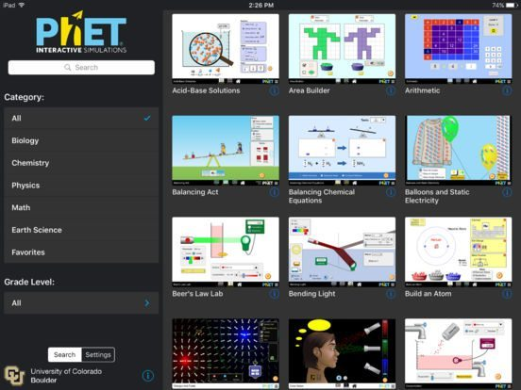

Figure 2.1 Variety of math and science options cite

One can take a look at the simulations by subject or grade level, view simulations marked as your favorites or search by keyword. Tapping the “i” next to each simulation displays a brief description and which topic it covers.

To help students engage in science and mathematics, PhET simulations are developed using concise design principles such as use of multiple representations e.g. object motion, graphs etc., interactivity between the user and the system components.

Several tools in the simulations provide an interactive experience: click and drag to interact with simulation features, use of sliders to increase and decrease parameters, options with radio buttons, taking if measurements with various instruments – rulers, thermometers, stopwatches.

As users interact with these tools, they get immediate feedback about the effect of the changes they made. This allows them to investigate cause-and-effect relationships and answer scientific questions through exploration of the simulation.

Provide citations… Is there only one category of user?

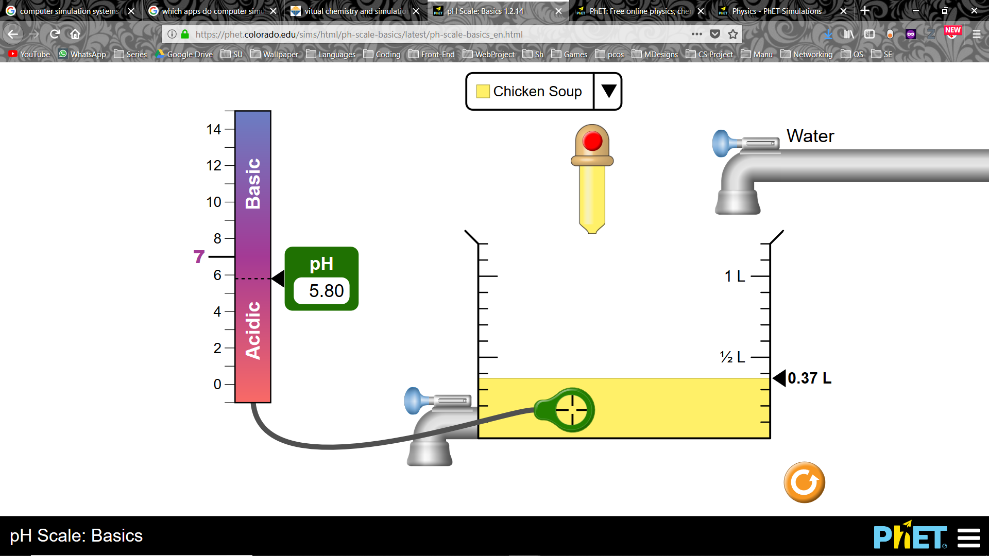

Figure 2.2 Simulation of pH Scale cite

### 2.2.2 ChemCollective Technology

ChemCollective is a collection of virtual labs, scenario-based learning activities, tutorials and concept tests for Chemistry. Teachers can use this content for their own laboratories, for alternatives to textbooks and for individual or team based experiments. It offers online simulations of Chemistry labs designed to allow learners to select from hundreds of standard reagents and manipulate them as within a real lab, but without the added cost of real equipment and potential hazards.

Within virtual labs, students have activities to set up practical equipment. The workbench allows students to complete titrations, make standard solutions and carry out many more protocols. The major advantage of the virtual lab is that students are given a choice of which equipment to use and will only get a correct answer once the experiment is set up correctly. This is helpful when teaching core practical skills for assessment. Provide citations

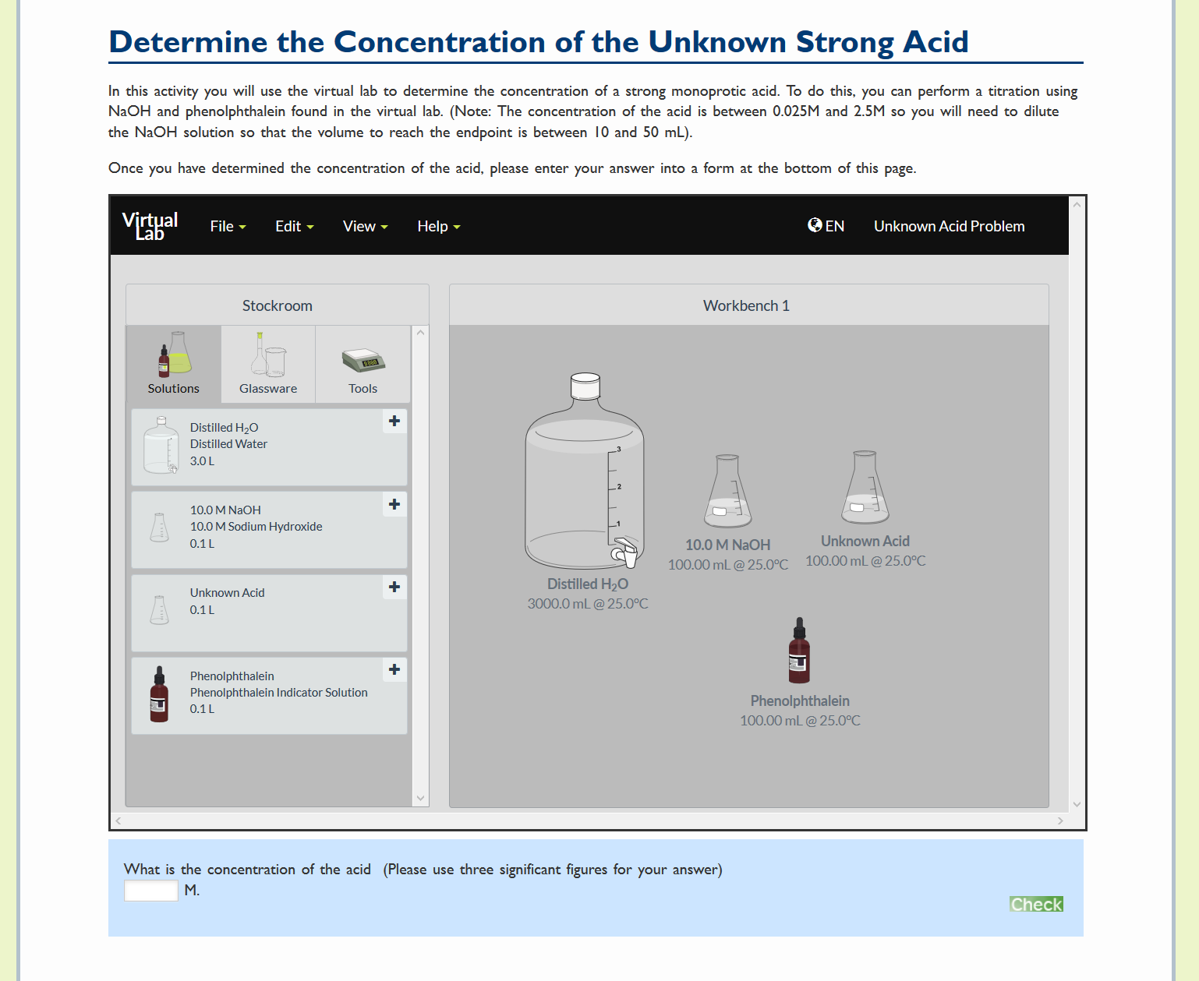

Figure 2.3 Conduction of a Concentration Experiment cite

### 2.2.3 Virtual Chemistry Lab Technology

Virtual Lab is an application based simulation system that is available for Microsoft’s Windows and Apple’s Mac OS X. It includes lab experiments which are accomplished through the use of real-time 3D graphics and pre-rendered animation. It requires Windows 8.1 or an older version whereas on a Mac, it must be powered by version 10.1.5 or newer. Describe how it works

The downside of this system is that it is lacking in experiments since it does not have a variety but only 4 lab experiments. It is also difficult to use as chemicals and solutions are not labelled. Provide citations

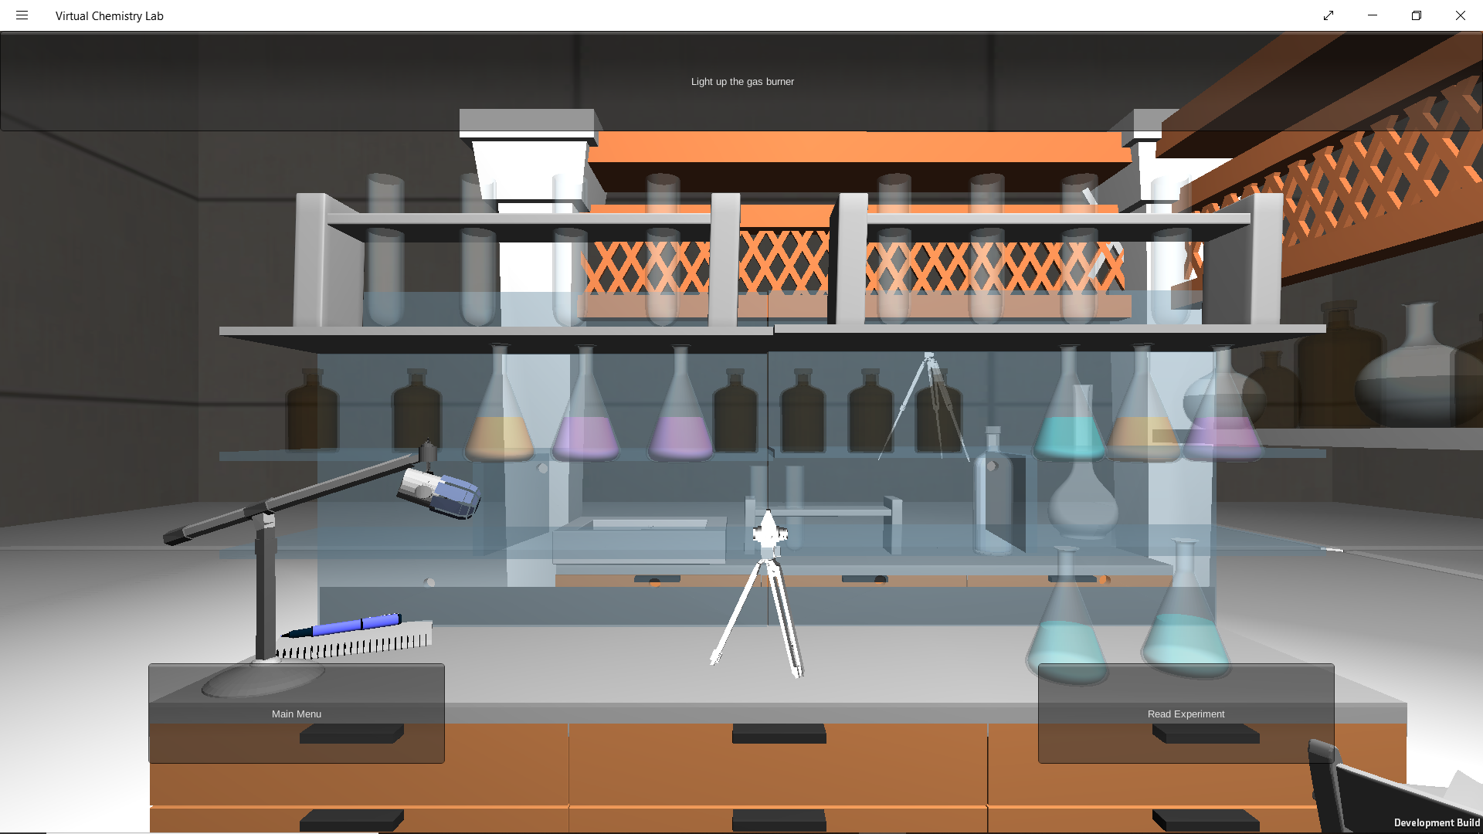

Figure 2.4 View of Lab cite

## 2.3 Existing Challenges in the use of the current systems

This study investigates the existing challenges associated with the use of the current virtual labs to teach students. The current web-based simulation of lab experiments have technological problems that plague any web site. They rely on servers that are not always in service. Updates of server or browser software may put earlier versions of virtual lab software out of commission. Students require adequate bandwidth to access the most interactive virtual labs, and home modems may not be adequate.

Some virtual labs are difficult to use and therefore require one to view tutorials to get a basic understanding of how to maneuver and manipulate the components within the lab.

There are training issues involved with students using virtual labs without supervision. When virtual labs link to other web sites, these links must be constantly checked for accuracy and continued existence. Web materials become out of date and require updating on a regular basis.

The huge amount of material on the web is daunting to many students and requires a critical eye to distinguish accurate from inaccurate web sites (MaKinster, Beghetto, & Plucker, 2002)

## 2.4 Gaps in the existing systems

Simulation of lab experiments have the potential to revolutionize the teaching of subjects, but gaps in its recognized potential and the actual applications still exist (Piccoli, Ahmad, & Ives, 2001). Most virtual labs are not designed and implemented correctly leading to over-simplifying and disregarding of health and safety in the lab environment. Health and safety education is particularly important in secondary level education and in the courses of higher level education that require lab experimentation, as this sets the ground for any future lab work the students might take part in. Ignorance in the health sector, may lead to serious injuries when a student for example, mixes in different quantities two toxic Chemistry solutions together in the lab whereas in the virtual environment it did not alert of any problems.

Virtual labs also generate data, which relies on the underlying assumptions, thus lacking the level of natural variation, and therefore students do not become familiar with poor or uncharacteristic data, nor will they learn how to deal with issues rising from these types of data such as mixing of high quantities of solutions leading to the creation of toxic gases.

**2.5 Conceptual Framework**

**Now you can discuss the solution in detail. Give a simple diagram to illustrate how the system works**

# Chapter 3: Development Methodology

## 3.1 Introduction

This chapter discusses the software development methodology to be used in the proposed project. It also highlights the system analysis and design approaches used. Finally, the chapter gives a description of the tools and techniques to be used in the project.

## 3.2 Software Development Methodology

This system puts into use the prototype model. The Prototyping Model is a Systems Development Methodology (SDM) within which a paradigm output (or an early approximation of a final system or product) is constructed, tested, and then reworked. It is done until an appropriate paradigm is achieved to help develop the entire system or product (Ganpatrao Sabale, 2012) . This model was chosen because it will require to have a lot of interaction with the end users. Prototyping will ensure that the users constantly work with the system and provide feedback which is incorporated in the prototype to result in a useable system. The final product is more likely to satisfy the user’s desire for look, feel and performance.

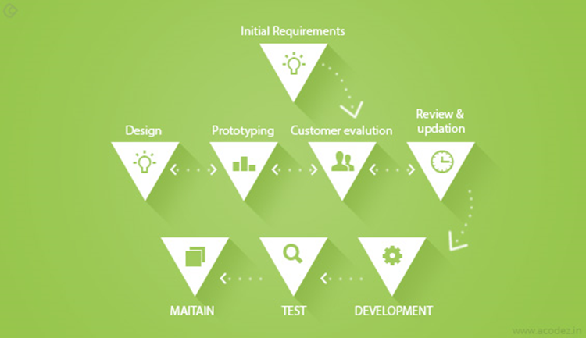

Figure 3.1 Prototyping Methodology

The first stage in prototyping is determining the system requirements and its major components. The main goal of this project is to enhance the learning process in Chemistry practicals specifically for high school students. The main is the use of java script enabled web browser. The main is that the users of the system need to have knowledge in Chemistry in order to use the system efficiently. Not functional or non-functional requirements

The second stage involves the evaluation of customers who will use the system. The main customers of this system are high school teachers and students. The students need the system to facilitate their learning of Chemistry practicals while teachers use the system to monitor the progress of their students in performing the practicals.

The third stage entails the designing of the system. A preliminary design of the system is sketched on paper and its functionalities are discussed with the stakeholders in order to improve the system.

In the fourth stage the design of the system is reviewed to evaluate whether it meets all the required functionalities.

In the fifth stage, the system is developed and all its proposed functionalities are implemented. The refinement process is repeated until the system meets all the requirements as stated by the stakeholders.

In the sixth stage the developed system is tested by being made available to the stakeholders. They evaluate the system to see whether it meets the requirements that they had stated.

In the final stage, the developed system is deployed for use. The system maintainers constantly improve the system and troubleshoot it for any errors.

## 3.3 System Analysis

System analysis is a technique that breaks down a system into its component pieces for the purpose of the studying how well those component parts work and interact to accomplish their purpose (Bentley, 2007). formatting

### 3.3.1 Functional requirements

Functional requirements specifies a function that a system or system component must be able to perform (Loucopoulos & Karakostas, 1995).

What are the functional requirements of the system?

1. A student should be able to log ing
2. A student should be able to…
3. A teacher should be able to…
4. A teacher should be able to set up laboratory experiments

### 3.3.2 Non-Functional requirements

Non-functional requirements (NFR) describe important constraints upon the development and behavior of a software system. They specify a broad range of qualities such as security, performance, availability, extensibility, and portability (Chung, Nixon, Yu, & Mylopoulos, 2012).

For the performance, the load time will be no more than 30 seconds for users accessing the website using a strong network connection. The database update process will roll back all related updates when any update fails. The system will be easy to use for both novices and users with experience from similar systems. The ability to easily manipulate the parameters in an experiment is an essential feature of the simulation environment. The concept of a lab table makes it possible to experiment freely with an object and it provides a simple method for saving results e.g. a titration experiment which requires a maximum of 3 values to be recorded. How will the non functional requirements be implemented?

### 3.3.3 System Narrative

Upon accessing the system, the student will login and will be presented with a dashboard which they can either to perform the practical on their own or enrol into a classroom generated by their teacher using an enrolment key. The student can select the set of experiment which they wish to perform and monitor their performance in the experiment. After enrolling to a class, the student will view the tasks assigned by the teacher and submit.

The teacher will also login into the system and be able to create a class and generate the enrolment key to be used by the student to access the virtual classroom. The teacher can set the practicals and view the submissions of their students. The teacher can then evaluate the submissions and send the results back to the students.

## 3.4 System Design

Systems design is defined as those tasks that focus on the specification of a detailed computer-based solution. Thus, whereas systems analysis emphasized on the business problem, systems design focuses on the technical or implementation concerns of the system (Bentley, Dittman, & Whitten, 2000)

### 3.4.1 Use Case Diagram

A **use case diagram** at its simplest is a representation of a user's interaction with the system that shows the relationship between the user and the different [use cases](https://en.wikipedia.org/wiki/Use_case) in which the user is involved.

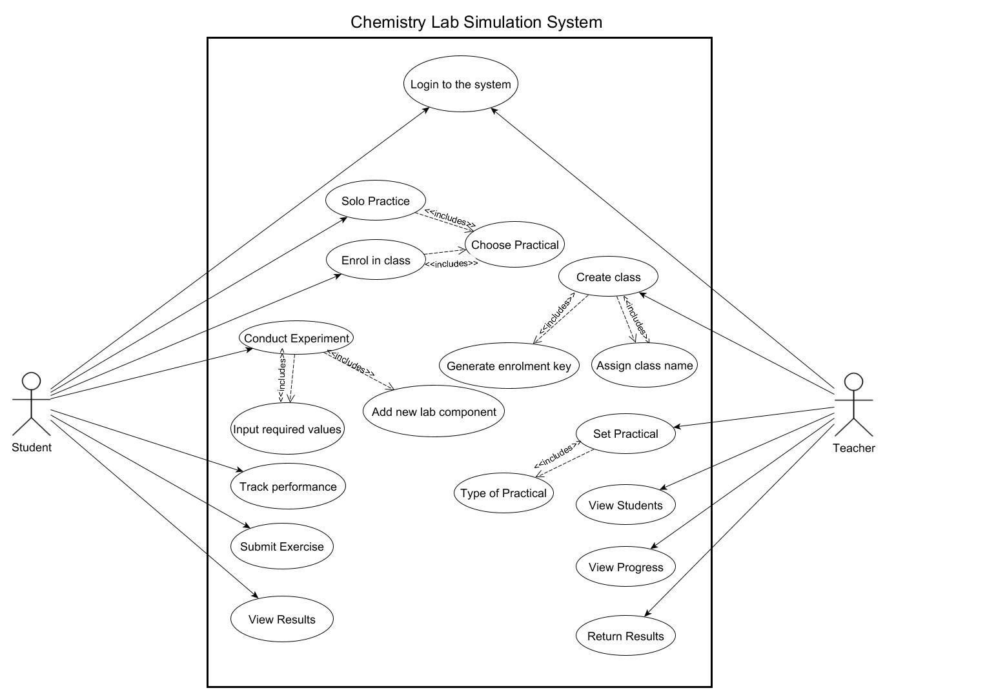

**Some of the use cases are not well labelled… they should be verbs… e.g. type of practical, solo practice**

### 3.4.2 DFD (Up to level 1)

A data flow diagram is a graphical representation of the flow of data and information through an information system describing its processes.

Provide a context level diagram first

You have repeated entities in the diagram



### 3.4.3 Entity Relationship Diagram

An entity relationship diagram shows the relationship of different entities that are stored in a database.

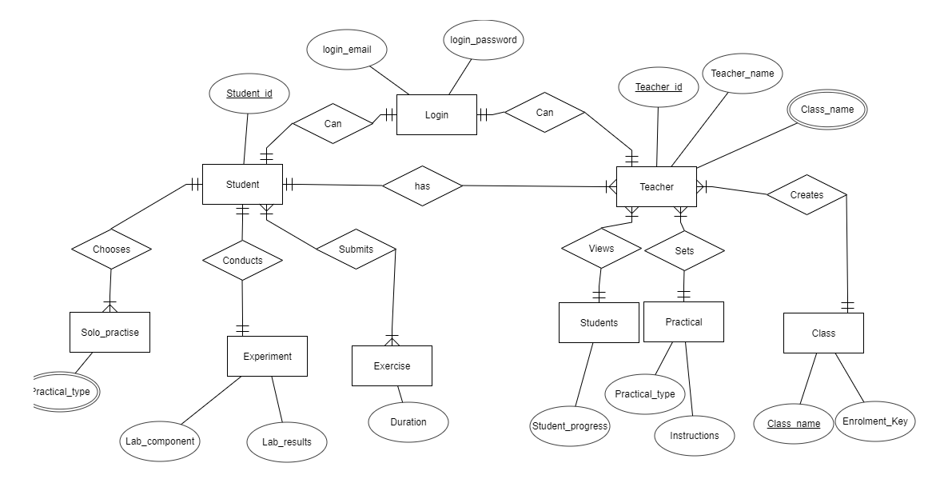

### 3.4.4 Database Schema

A database schema is the skeleton structure that represents the logical view of an entire database and how the data is related.

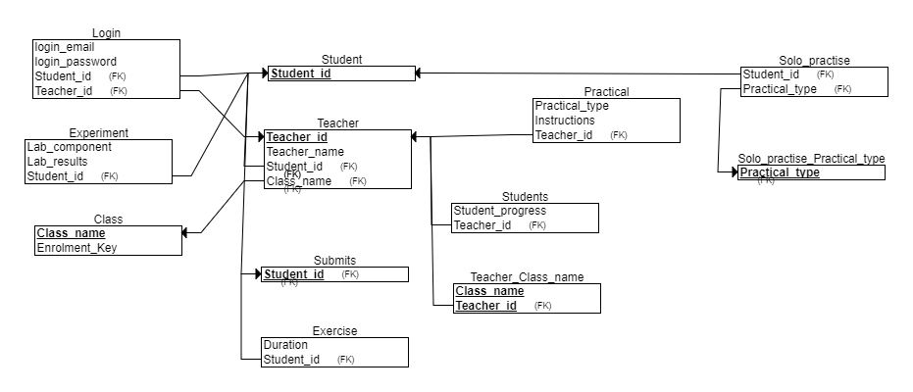

## 3.5 System Development Tools and Techniques

### 3.5.1 Visual Studio Code

Visual studio code will be the main development environment used to build the system. All the code will be written and tested using the text editor.

### 3.5.2 JavaScript

Java script is the main scripting programming language used to process the major functionalities used within the web application.

### 3.5.3 HTML

The standard mark-up language used to develop the web pages will be HTML5.

### 3.5.4 CSS

CSS will be used to style all the web pages and provide an appealing interface to the users of the web application.

### 3.5.5 PHP

PHP will be used to handle all the server-side scripts and processes that link the web application to a server and database.

### 3.5.6 Bootstrap

Bootstrap will be used as a framework to develop the main dashboards.

## 3.6 Deliverables

This proposed system will have:

### 3.6.1 Student’s Module

The student shall login to the system and will choose to either perform an experiment alone or to join a class using a code. In the class, the student can view the tasks assigned by the tutor.

### 3.6.2 Teacher’s Module

A teacher will use the system to assign tasks to students and monitor their progress in performing the assigned tasks. Create lab experiments?

# References

Bentley, L. D. (2007). *Systems Analysis and Design for the Global Enterprise* (7th edition). Boston: Irwin/McGraw-Hill.

Bentley, L. D., Dittman, K. C., & Whitten, J. L. (2000). *Systems analysis and design methods*. Irwin/McGraw Hill.

Chung, L., Nixon, B. A., Yu, E., & Mylopoulos, J. (2012). *Non-Functional Requirements in Software Engineering*. Springer Science & Business Media.

Ganpatrao Sabale, R. (2012). Comparative Study of Prototype Model For Software Engineering With System Development Life Cycle. *IOSR Journal of Engineering*, *02*(07), 21–24. https://doi.org/10.9790/3021-02722124

Jensen, N., Seipel, S., von Voigt, G., Raasch, S., Olbrich, S., & Nejdl, W. (2004). Development of a virtual laboratory system for science education and the study of collaborative action. In *EdMedia: World Conference on Educational Media and Technology* (pp. 2148–2153). Association for the Advancement of Computing in Education (AACE).

Josephsen, J., & Kristensen, A. K. (2006). Simulation of laboratory assignments to support students’ learning of introductory inorganic chemistry. *Chemistry Education Research and Practice*, *7*(4), 266–279.

Loucopoulos, P., & Karakostas, V. (1995). *System Requirements Engineering*. New York, NY, USA: McGraw-Hill, Inc.

MaKinster, J. G., Beghetto, R. A., & Plucker, J. A. (2002). Why Can’t I Find Newton’s Third Law? Case Studies of Students’ Use of the Web as a Science Resource. *Journal of Science Education and Technology*, *11*(2), 155–172. https://doi.org/10.1023/A:1014617530297

Piccoli, G., Ahmad, R., & Ives, B. (2001). Web-Based Virtual Learning Environments: A Research Framework and a Preliminary Assessment of Effectiveness in Basic IT Skills Training. *MIS Quarterly*, *25*(4), 401–426. https://doi.org/10.2307/3250989

# Appendices

## Appendix A: GANTT Chart

